**Fundamentals of Programming**

**Lab Manual:07**

**Submitted to: M . Affan**

**Submitted By: Nafeel Javaid**

**Roll no:465554**

**Course:ME-15**

**Section: A**

**Task:01**

**.**  #include<iostream>

using namespace std;

int main() {

int ar[10];

cout<<"Enter 10 integers: ";

for(int i=0;i<10;i++)

cin>>ar[i];

}

cout<<"The Sequence is: ";

for(int i=0;i<10;i++) {

cout<<ar[i]<<" ";

} return 0;

}

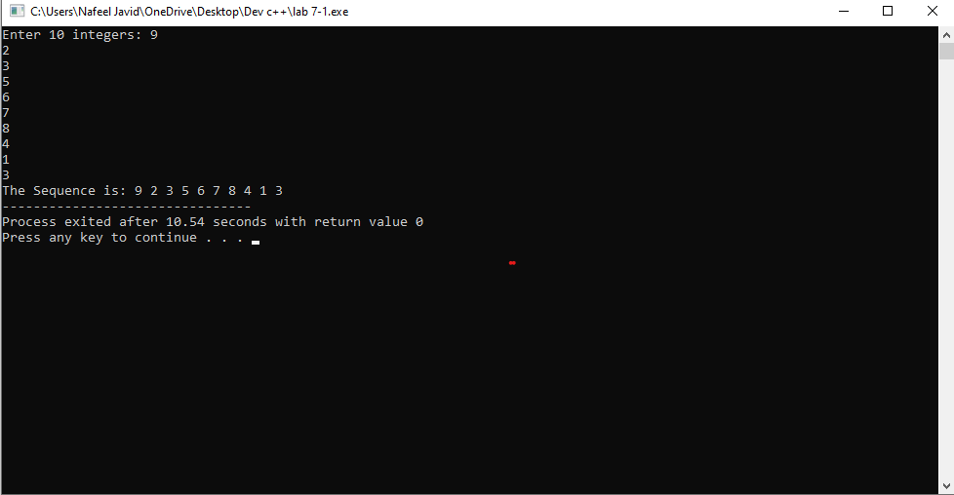

**Task:02**

**.** #include<iostream>

using namespace std;

int main() {

int ar[5],s(0),p(1);

cout<<"Enter the integers: ";

for(int i=0;i<5;i++) {

cin>>ar[i];

}

for(int i=0;i<5;i++) {

s+=ar[i];

p*=ar[i];

}

cout<<"The sum is: "<<s<<endl;

cout<<"The product is: "<<p<<endl;

return 0;

}

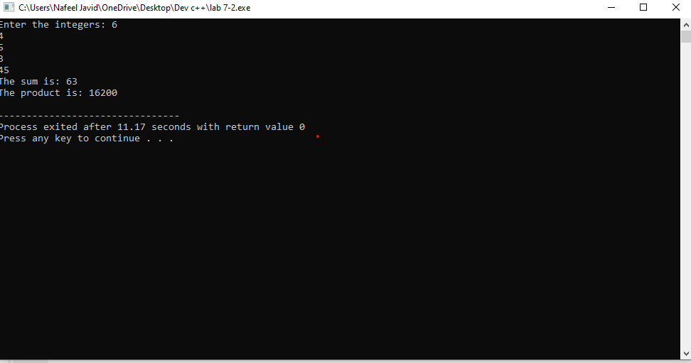

**Task:03**

. #include <iostream>

using namespace std;

int main() {

int n;

cout << "Enter the number of rows for the diamond pattern: ";

cin >> n;

if (n % 2 == 0) {

cout << "Please enter an odd number for a symmetric diamond pattern." << endl;

}

int s = n / 2;

for (int i = 0; i < n / 2 + 1; ++i) {

for (int j = 0; j < s; ++j) {

cout << " ";

}

for (int k = 0; k < 2 * i + 1; ++k) {

cout << "*";

}

cout << endl;

--s;

}

s= 1;

for (int i = n / 2 - 1; i >= 0; --i) {

for (int j = 0; j < s; ++j) {

cout << " ";

}

for (int k = 0; k < 2 * i + 1; ++k) {

cout << "*";

}

cout <<endl;

++s;

}

return 0;

}

